1.Задание
(1) Дано комплексное число z
- Записать z в показательной, тригонометрической и алгебраической форме, изобразить.
- Записать u=z^{n} (где n=(-1)^{N}(N+4), N – номер варианта) в показательной, тригонометрической и алгебраической форме, изобразить.
- Записать в показательной и тригонометрической форме каждое значение w_{k} (k=0..m-1) корня m=10, изобразить на комплексной плоскости вместе с числом z.
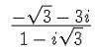
(2) Изобразить на комплексной плоскости
(3) Найти все значения z и изобразить на комплексной плоскости

2.Теоретические основания:
Математика. Комплексные числа и работа с ними
3.Код
> restart;
> with(LinearAlgebra): with(plots):
> z := (-sqrt(3) - 3*I)/(1 - I*sqrt(3));
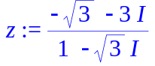
> Z := <Re(z), Im(z)>:
> 'z' = Z[1] + Z[2]*I;
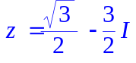
>
> r := Norm(Z,2);
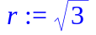
> phi := VectorAngle(Z, <1,0>);
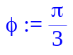
> if evalf(VectorAngle(Z, <0,1>)) > evalf(Pi/2) then phi := 2*Pi-phi; fi;
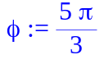
> 'z' = 'e'^(I*phi);
>
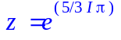
> 'z' = r*('cos'(phi) + I*'sin'(phi));
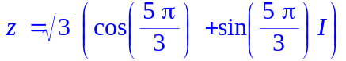
> pl := {arrow(<0,0>, Z, color = "black", width = 0.03), textplot([Z[1]*1.1, Z[2]*1.1, "Z"])}:
> pl := pl union {plot([cos(t), sin(t), t=0..phi], legend = "угол")}:
> display(pl);
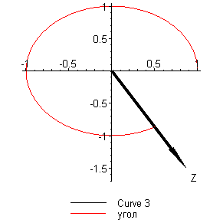
> ##2
> n := (-1)^12*(12+4);
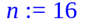
> u = r^n*exp(i*n*phi);
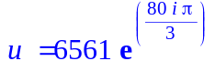
> u = r^n*('cos'(n*phi) + I*'sin'(n*phi));
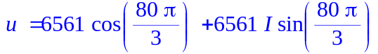
> u := r^n*(cos(n*phi) + I*sin(n*phi));
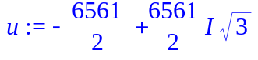
> ;
> pl := {arrow(<0,0>, <Re(u), Im(u)>, color = "black"), textplot([Re(u)*1.1, Im(u)*1.1, "u"])}:
> pl := pl union {plot([r^n*cos(t), r^n*sin(t), t=0..argument(Re(u) + I*Im(u))], legend = "угол")}:
> display(pl);
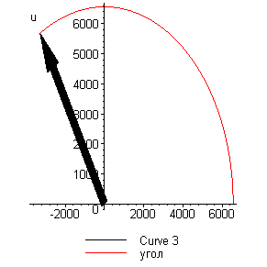
>
> ##3
> n := 10:
> pl :={}:
solution := {solve(w^10 = z)}:
> for i from 1 by 1 to 10 do
print("");print("root ", i);print("");
w[i] = evalf(Re(simplify(solution[i]))) + evalf(Im(simplify(solution[i])))*I;
w[i] = r^(1/n)*'e'^(I*((phi + 2*Pi*i)/n));
w[i] = r^(1/n)*('cos'(((phi + 2*Pi*i)/n)) + 'sin'(((phi + 2*Pi*i)/n)*I));
#w = simplify(solution[i]);
print("");print("");print("");
od;

for i from 1 by 1 to 10 do
pl := pl union {arrow(<0,0>, <Re(simplify(solution[i])), Im(simplify(solution[i]))>, color = "black")}:
pl := pl union {textplot([Re(simplify(solution[i]))*1.2, Im(simplify(solution[i]))*1.2, cat("w ", i)], color = blue)}:
pl := pl union {plot([r^(1/n)*cos(t), r^(1/n)*sin(t), t=0..2*Pi])}:
od:
pl := pl union {arrow(<0,0>, Z, color = "black"), textplot([Z[1],Z[2], "z"], color = blue), plot([r*cos(t), r*sin(t), t=0..phi]), plot([cos(t), sin(t), t=0..phi])}:
display(pl);
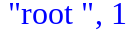
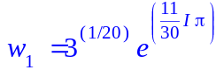
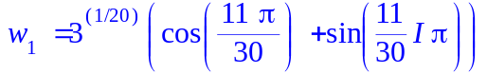
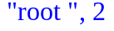
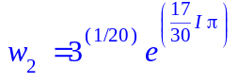
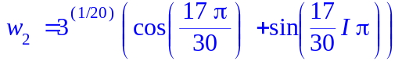
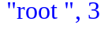
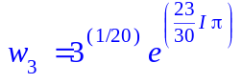
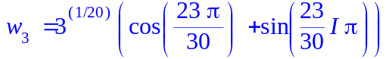
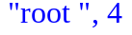
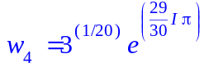
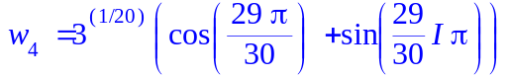
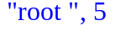
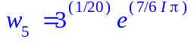
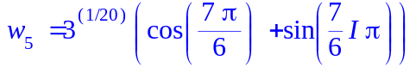
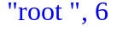
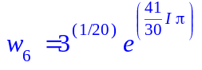
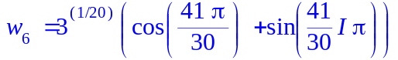
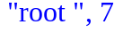
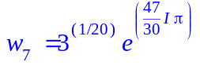
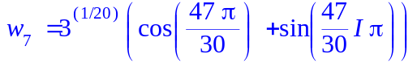
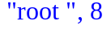
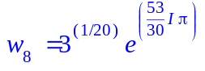
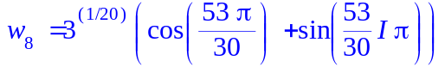
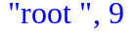
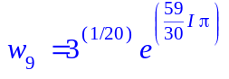
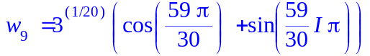
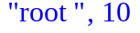
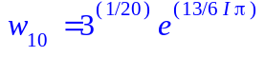
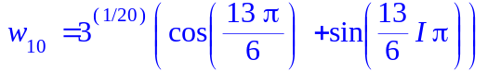
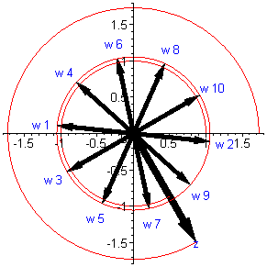
>

> #######task2
> #D = {z : |z| > 3, |z-4| <= 2, -Pi/2 <=phi< 0 }
>
> pl := {implicitplot([sqrt((x-4)^2+y^2) = 2, sqrt(x^2 + y^2) = 3], x = 0..10, y = -10..0)}:
> for i from 0 by 0.05 to 6 do
for j from -3 by 0.05 to 0 do
if (evalf(sqrt((i-4)^2+j^2)) <= 2) and evalf(sqrt((i)^2+j^2) > 3)then
pl := pl union {pointplot(<i,j>)};

fi; od:
od:
> #display(pl);
> pl1 := implicitplot((x-4)^2+y^2 <= 4, x = 0..10, y = -10..0, filledregions, coloring = [red, white]):
> pl2 := implicitplot(x^2+y^2 <= 9, x = 0..10, y = -10..0, filledregions = true, coloring = [white, white]):
display(pl2, pl1, view = [-10..10, -10..10]);
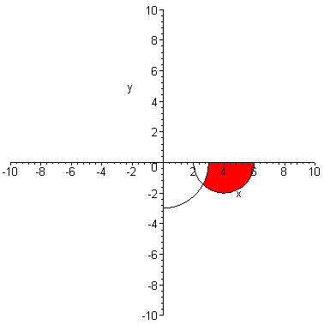
> ###3
> z := 'z':
> # z^5 +I - 1 = 0; z^4 - 4*I*z^2 - 3 = 0;
> solution := {solve(z^5 +I - 1 = 0)}:
> view_sol := proc(k)
local pl, solution,i;
pl := {};
solution := {solve(k)};
for i from 1 by 1 to nops(solution) do
pl := pl union {arrow(<0,0>, <Re(simplify(solution[i])), Im(simplify(solution[i]))>, color = "black")}:
pl := pl union {textplot([Re(simplify(solution[i]))*1.2, Im(simplify(solution[i]))*1.2, cat("w ", i)], color = blue)}:
pl := pl union {plot([r^(1/n)*cos(t), r^(1/n)*sin(t), t=0..2*Pi])}:
od:
display(pl);
end proc:
> view_sol(z^5 +I - 1 = 0);
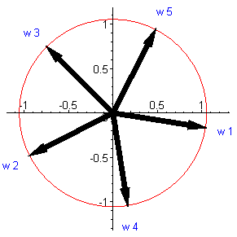
> view_sol(z^4 - 4*I*z^2 - 3 = 0);
